

eInvoicing Implementation Guide

December 2024

December 2024

**Contents**

[Purpose 3](#_Toc184291247)

[Summary Checklist 3](#_Toc184291248)

[Section 1 – eInvoicing and Peppol 101 4](#_Toc184291249)

[Peppol overview 4](#_Toc184291250)

[Anatomy of a Peppol eInvoice 6](#_Toc184291251)

[Data and security 9](#_Toc184291252)

[Peppol documentation 9](#_Toc184291253)

[Section 2 – Before you implement 12](#_Toc184291254)

[Scope considerations 12](#_Toc184291255)

[Implementation options 13](#_Toc184291256)

[Getting ready 14](#_Toc184291257)

[Tips from early adopters 16](#_Toc184291258)

[Section 3 – Implementing 17](#_Toc184291259)

[Invoice content and mapping 17](#_Toc184291260)

[Other implementation considerations 22](#_Toc184291261)

[Tips from early adopters 24](#_Toc184291262)

[Implementation task checklist 24](#_Toc184291263)

[Section 4 - Testing 25](#_Toc184291264)

[Testing considerations 25](#_Toc184291265)

[Testing checklist 26](#_Toc184291266)

[Appendix 1 – Troubleshooting 27](#_Toc184291267)

# Purpose

This document provides information and guidance material to assist with the technical side of an eInvoicing implementation project.

|  |
| --- |
| **The MBIE eInvoicing team is here to help** Contact us at [eInvoicing@mbie.govt.nz](mailto:eInvoicing@mbie.govt.nz) for implementation and customer/supplier onboarding advice. |

# Summary Checklist

| Executive Summary – Key Tasks | Done ✓ | |
| --- | --- | --- |
| **Section 1 – eInvoicing and Peppol 101**  🞎 Understand eInvoicing and Peppol, and how it is different to your current ways of invoicing  🞎 Familiarise yourself with Peppol documentation and Industry Practice Statements |  |
| **Section 2 – Before you implement**  🞎 Plan your implementation:   * Project scope * Implementation pathway/s and vendor selection * Credit note handling * Other Peppol eProcurement/P2P documents   🞎 Review and update current processes for eInvoicing  🞎 Capture NZBN data (the eInvoice ‘address’) for customers and/or suppliers  🞎 Plan Crown invoices and organisational part numbers |  |
| **Section 3 – Implementing**  🞎 Implement your invoice content and mapping:   * Mandatory fields * Best practice fields * Attachments   🞎 Implement any invoice validation and business rules  🞎 Understand interoperability trade-offs  🞎 Configure message acknowledgements/error messages |  |
| **Section 4 – Testing**  🞎 Develop and implement your testing plan - refer to detailed testing checklist |  |

# Section 1 – eInvoicing and Peppol 101

This section introduces eInvoicing and Peppol ‘must knows’ and walks you through the documentation available.

### Peppol overview

eInvoicing is the messaging channel where invoice data is sent from a supplier’s (seller’s) financial system and received in a customer’s (buyer’s) financial system.

The New Zealand and Australian governments have committed to a joint approach to eInvoicing using the Peppol interoperability framework. Peppol is a global standardised framework that enables businesses to exchange procurement documents electronically.

The Peppol eInvoicing network incorporates an established set of common business processes and technical standards. This provides an interoperable and secure network using consistent electronic messaging protocol and formats, and digital signature technologies to secure message content.

Peppol standards are based on a standardised XML format known as Universal Business Language (UBL). Invoice senders and receivers (and their invoicing software) communicate via an Access Point Provider – secure gateways that connect businesses to the eInvoicing network.

eInvoicing sends and receives structured eInvoice data. The invoice is validated and structured (based on the Peppol standard) by the sender (supplier) and comes through to the receiver’s (customer’s) financial system in a structured format with no extra processing required. This is different to receiving invoices through channels like optical character recognition (OCR), which takes an unstructured invoice and completes extra processing steps to provide the data in a structured format.

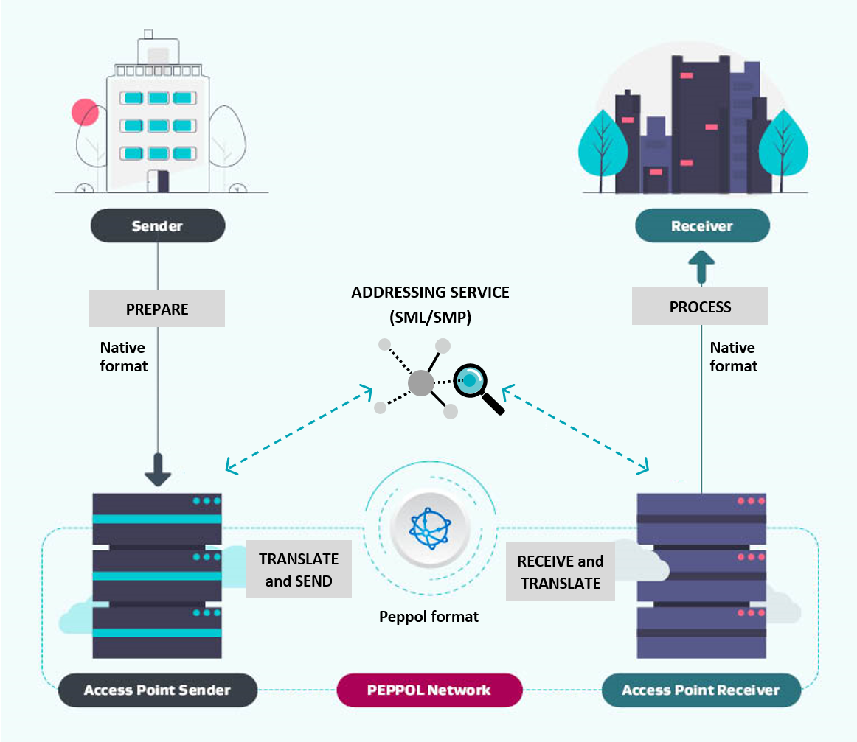

Corner 1: Sender (Supplier)

The supplier generates an invoice in their accounts receivable software, which is then sent to their Access Point Provider. The customer’s New Zealand Business Number (NZBN) is included as the ‘address’ of the eInvoice.

Corner 2: Sender’s (Supplier’s) Access Point Provider

The supplier’s Access Point Provider performs validation checks including Peppol network checks, invoice format and validity checks, confirming the legitimacy of the invoice sender and whether the receiver can receive the eInvoice (checking the customer’s NZBN in the Peppol Service Metadata Locator - SML). They then send the eInvoice to the customer’s Access Point Provider via the Peppol network.

Corner 3: Receiver’s (Customer’s) Access Point Provider

The customer’s Access Point Provider receives the validated eInvoice from the supplier’s Access Point Provider and sends it electronically to the customer’s accounts payable software. They may first perform validation checks on the eInvoice using any business rules provided by the receiver.

Corner 4: Receiver (Customer)

The invoice lands in the customer’s accounts payable software. Note, if there is data that requires confirmation, such as coding, the invoice will usually land in an exception queue for manual intervention.

| Roles and definitions |  |
| --- | --- |
| 1. Sender (Supplier) | The supplier of the goods/services   * Accounts receivable team * Business software used by the supplier |
| 2. Sender’s Access Point Provider | The service provider that translates and sends the supplier’s eInvoice data |
| 3. Receiver’s Access Point Provider | The service provider that receives and translates the eInvoice data for the customer |
| 4. Receiver (Customer) | The customer/buyer of the goods/services   * Accounts payable team * Business software used by the customer |

### Anatomy of a Peppol eInvoice

A Peppol eInvoice is machine readable, structured data in XML format. eInvoices are comprised of structured data which is mapped to fields in an organisation’s sending and receiving finance systems. These fields correspond to normal invoice data.

Implementing eInvoicing can be summarised by changing the way your finance system inputs/outputs invoices, from traditional PDF invoices to structured XML eInvoices.

The XML view provides a technical view of the same eInvoice as XML (the data format used for eInvoicing). Most software systems also provide a ‘natural view’ of an eInvoice for easy readability – usually either a rendered invoice mock-up of the XML eInvoice or a rendered PDF invoice. Refer to the Technical self service resource on the eInvoicing website for an interactive comparison.

**PDF invoice**

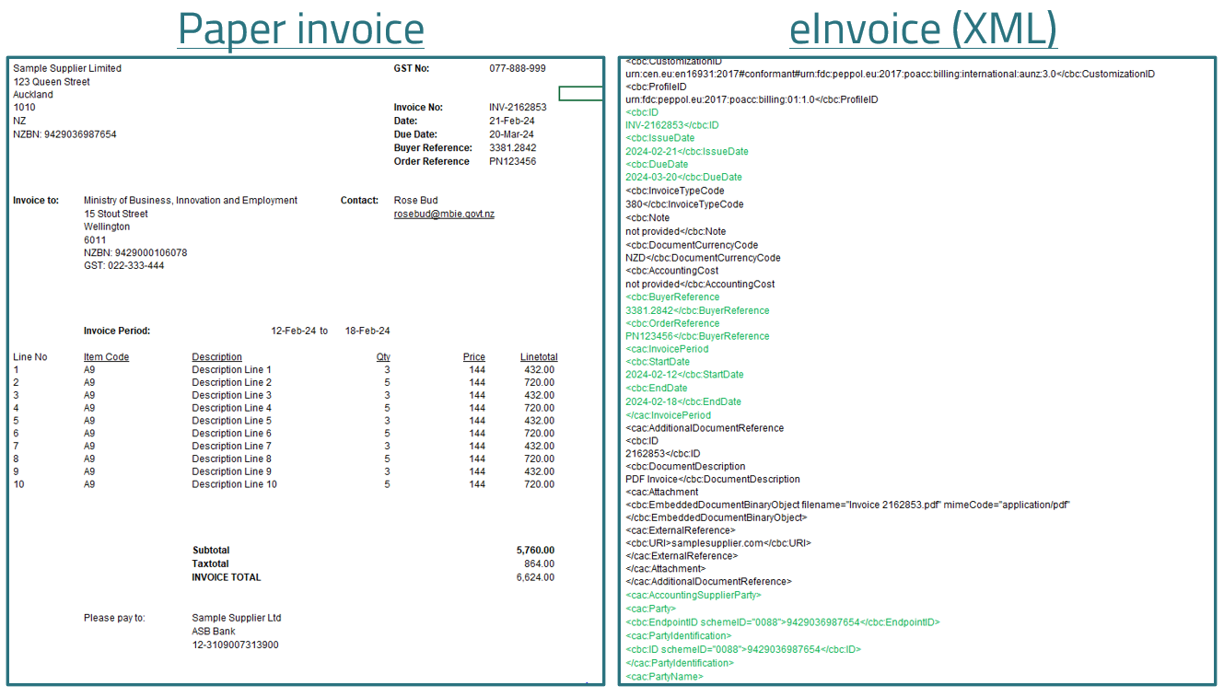

**Peppol eInvoice (XML)**



### Data and security

A key benefit of eInvoicing is the secure transmission, receipt and validation of data. eInvoices are impossible to lose, minimise the risk of fake or compromised invoices, and reduce the chance of paper or PDF invoices being intercepted.

There are different layers of security built into the eInvoicing network, including:

* AS4 for transmission of asynchronous messages between Access Points
* Public key infrastructure establishes a trusted network
* Digital certificate for Access Points and Service Metadata Publishers
* ISO27001 or ASD/NZISM certification
* Know Your Customer (KYC) compliance requirements.

Accreditation of Access Point providers is maintained by the New Zealand and Australian Peppol Authorities assessing encryption in transit, encryption at rest, separation of duties, security monitoring practices and multifactor authentication.

eInvoices are sent and received directly from the customer’s and supplier’s software systems in a similar way to how they are now – just more efficiently and securely. eInvoicing automates the data coming into your financial system, so you’ll still need to perform your standard checks and business processes for confirming, approving and paying legitimate invoices like you do now for emailed and posted invoices.

Digital disruption is avoided, where:

* Email interception is impossible, making eInvoicing a safer method
* Manipulation of invoices is minimised.

Third parties will not have visibility of eInvoices sent/received via the Peppol network.

Invoice data (including metadata) is not held by Access Point providers - data is only passed through the Peppol network. Customer data (e.g. for Know Your Customer purposes) may be held by an Access Point provider, but this must be specified in a contract.

### Peppol documentation

Review Peppol documentation and industry practice statements before you start your implementation project.

#### New Zealand Peppol standard

The New Zealand and Australian Peppol community is in the first phase of a 2-part planned migration from the current [A-NZ extension to the Peppol specification](https://github.com/A-NZ-PEPPOL/A-NZ-PEPPOL-BIS-3.0), to Peppol PINT. PINT is an international invoice specification to increase global interoperability.

A-NZ extension to the Peppol specification (until May 2025)

In New Zealand the [A-NZ extension to the Peppol specification](https://github.com/A-NZ-PEPPOL/A-NZ-PEPPOL-BIS-3.0) **must** be used until 15 May 2025, as a transition measure during the move to PINT. This extension has built in syntax to manage country specific GST and multiple payment means in New Zealand and Australia. The A-NZ extension supports the Invoice, Credit Note and Self-Billing Invoice document types. The documentation contains detailed technical specifications, validation documents and message examples.

PINT

The PINT A-NZ extension is now mandatory for receivers:

* Peppol service providers must have the capabilities to support the receipt of PINT A-NZ invoices and PINT A-NZ credit notes.
* Receivers should also support the [A-NZ extension to the Peppol specification](https://github.com/A-NZ-PEPPOL/A-NZ-PEPPOL-BIS-3.0).
* PINT A-NZ is optional (but recommended) for senders.

**May 15th, 2025:** PINT A-NZ becomes mandatory for both senders and receivers:

* Peppol service providers must support the sending and receipt of PINT A-NZ invoices and credit notes
* The current A-NZ BIS specification will no longer be supported.

Where your organisation has previously used the BIS specification for sending or receiving, your service provider will handle the transition to ANZ-PINT as outlined above.

|  |
| --- |
| Resource - Github  The joint [A-NZ Peppol Github repository](https://github.com/A-NZ-PEPPOL/A-NZ-PEPPOL-BIS-3.0) contains:   * The A-NZ extension to the Peppol specification. * Guidance documents called ‘industry practice statements’ (see below) * A range of artefacts relating to the A-NZ extension to the Peppol specification, including [Peppol UBL sample message examples](https://github.com/A-NZ-PEPPOL/A-NZ-PEPPOL-BIS-3.0/tree/master/Message%20examples) (XML payloads). |

#### Global Peppol BIS billing specifications​

The Peppol Business Interoperability Specification 3.0 (BIS) provides a set of specifications (syntax, rules, and code lists) for implementing a Peppol business process. The BIS 3.0 determine the structure and format of Peppol documents. ​

|  |
| --- |
| Refer to the official Peppol documentation at [Documentation - OpenPeppol](https://peppol.org/documentation/) |

#### Industry practice statements

[**A-NZ industry practice statements**](https://github.com/A-NZ-PEPPOL/A-NZ-Industry-Practice-Statements) contain guidance, recommendations, business considerations and use cases to support Peppol implementation and interoperability in New Zealand and Australia. ​

There are six industry practice statements to review:​

| Industry Practice Statement | Scope |
| --- | --- |
| 1. [Invoice content industry practice statement](https://github.com/A-NZ-PEPPOL/A-NZ-Industry-Practice-Statements/blob/main/A-NZ_Industry_Practice_Statement_%20Invoice_Content_v1.1.docx)​ | Guidance on additional invoice content fields to include in eInvoices you send and receive, to maximise interoperability. |
| 2. [Consistent data mapping industry practice statement](https://github.com/A-NZ-PEPPOL/A-NZ-Industry-Practice-Statements/blob/main/A-NZ%20ASWG_Consistent%20Data%20Mapping%201.0.docx)​ | Guidance on invoice data mapping to assist with consistent interpretation and implementation of the A-NZ invoice specification and avoid processing issues (delays or rejections).​ |
| 3. [Communicating invoice status industry practice statement](https://github.com/A-NZ-PEPPOL/A-NZ-Industry-Practice-Statements/blob/main/A-NZ%20Industry%20Practice%20Statement_Communicating%20Invoice%20Status_v1.0.docx)​ | Guidance for communicating invoice status via the Peppol network, including business scenarios and UBL examples.​ |
| 4. [Attachments industry practice statement](https://github.com/A-NZ-PEPPOL/A-NZ-Industry-Practice-Statements/blob/main/A-NZ%20Industry%20Practice%20Statement_Understanding%20and%20managing%20attachments%20in%20eInvoices%20and%20eCredit%20Notes_v1.docx)​ | Guidance on attachments supported by Peppol, how attachments can support different use cases, and the varying capabilities of solutions to support attachments.​ |
| 5. [Billing use cases industry practice statement](https://github.com/A-NZ-PEPPOL/A-NZ-Industry-Practice-Statements/blob/main/A-NZ%20Industry%20Practice%20Statement_specific%20billing%20use%20cases_V1.0.docx)​ | Essential reading for any sender​. Guidance, implementation options and use cases for billing scenarios. This includes billing to a third party, opening balances, conditional discounts, consolidated invoices, adjusting a previous bill, and payment arrangements. |

# 

# Section 2 – Before you implement

This section introduces key scope considerations for an eInvoicing project.

### Scope considerations

#### eInvoicing send vs receive capability

Many large organisations choose to separate sending and receiving eInvoices into separate implementation projects, though they can choose to implement simultaneously. Separate implementation projects can be useful if the systems the organisation uses for sending and receiving invoices are different. The organisation would typically choose to implement the capability giving the most benefit first – usually based on volumes of invoices.

eInvoicing is an additional channel that an organisation can add to their existing invoicing system/s. The diagrams below show how eInvoices can exist alongside current invoice processing systems.

Sending invoices

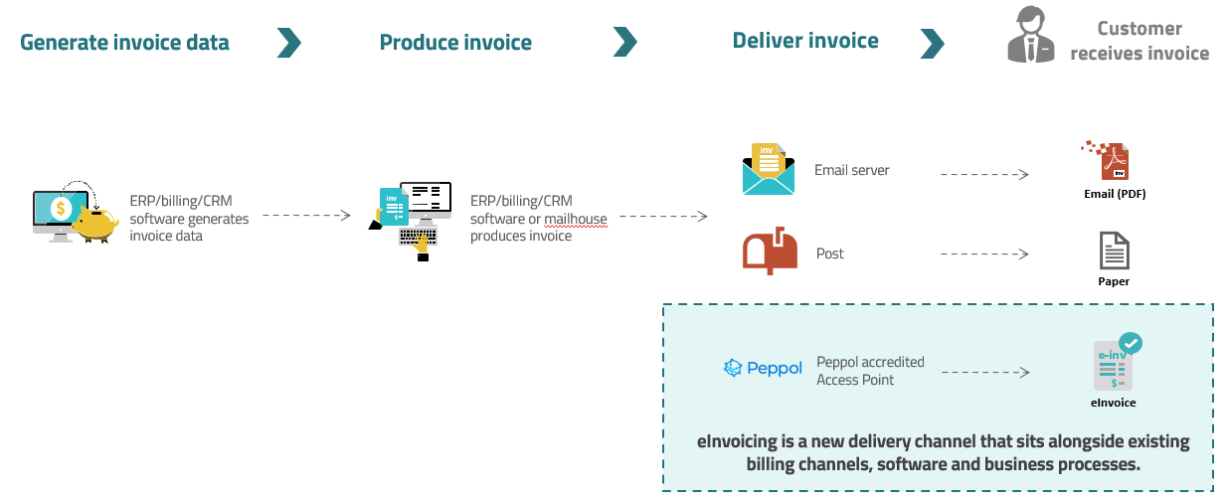

Receiving invoices

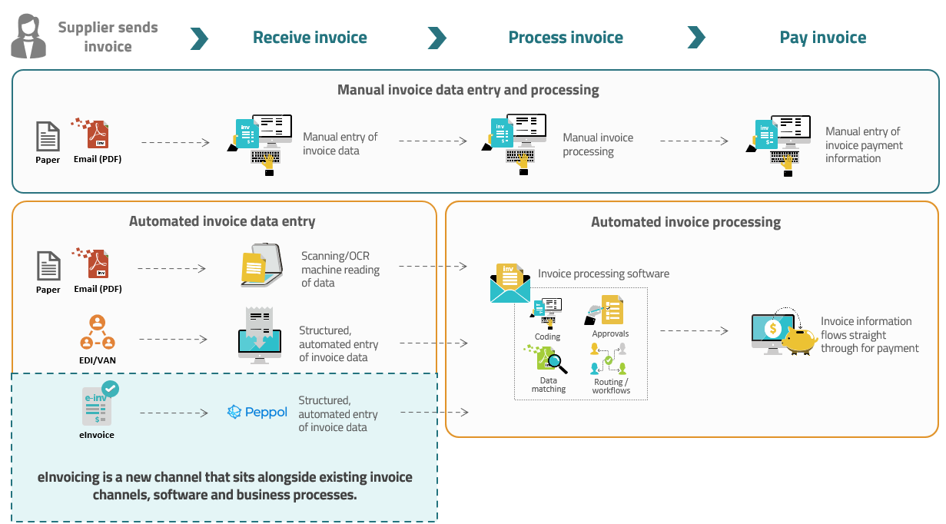

### Implementation options

eInvoicing can be implemented using a range of different software/systems and is most effective when implemented using natural business software and integrates with existing systems and processes. There is no single recommended pathway for implementing eInvoicing. Think about eInvoicing simply as an additional channel that sits alongside existing invoice channels (e.g. email, post, EDI), within the system/s you currently use to send/receive invoices.

This may mean that the same software is used for all forms of eInvoicing (send/receive), or that eInvoicing is implemented using different systems that are already in place within the organisation (i.e. to send and receive eInvoices).

Identify business software options to send and receive eInvoices. Common options include:

#### Example 1: ERP (Sending/Receiving eInvoices)

* If you send/receive and process invoice via the organisation’s ERP
* eInvoicing may require upgrading to a cloud version and additional invoice sending/processing modules – talk to the provider and IT team

#### Example 2: AR Automation/Billing Software/Mailhouse (Sending eInvoices)

* If you use additional software (outside of the organisation’s ERP) to send B2B invoices
* If invoices/generate invoice PDFs are sent using a mailhouse or billing provider
* eInvoicing becomes a customer channel preference

#### Example 3: AP Automation/OCR Provider (Receiving eInvoices)

* If you use additional software (outside of the organisation’s ERP) to receive and process invoices
* eInvoicing becomes an additional channel to receive supplier invoices

#### Example 4: EDI/VAN Network (Sending/Receiving eInvoices)

* Many EDI/VAN networks offer Peppol as a channel

There are two options to connect to the Peppol network:

* **Option 1:** Use eInvoicing capable software (which has a connection to the Peppol network built in)
* **Option 2:** Connect with an eInvoicing Access Point Provider.

#### Option 1 – Use eInvoicing capable software

eInvoicing works best using the organisation’s natural business software.

Over 55 invoice software products support eInvoicing:

* Check the list of eInvoicing capable software products in New Zealand. If the software you use to send/receive invoices is on this list, contact your account manager for details about how to enable eInvoicing
* If your software isn’t on the list, it’s still possible that there is eInvoicing functionality, so it’s worth checking with your software provider.

Implementation instructions vary by software, so check with your provider for details.

|  |
| --- |
| **Resource**  * List of [eInvoicing capable software products](https://www.einvoicing.govt.nz/software/software-products) |

#### Option 2 – Integrate with an eInvoicing Access Point provider

Access Point providers are secure gateways that connect businesses and software to the eInvoicing network. You need an access point provider to connect you to the Peppol eInvoicing network if:

* Your software (or its current version) is not yet eInvoicing capable, or
* Your software is eInvoicing capable but requires you to set up a separate access point connection (most eInvoicing capable software providers have an in-built access point connection to the eInvoicing network. However, some ERPs require you to also set up your own Peppol access point connection).

Refer to the diagram and role of an Access Point provider in Section 1.

Choosing an Access Point

Access Point providers offer a wealth of eInvoicing expertise and many offer additional value-add services. If you’re working with an Access Point, their contribution will be significant in covering the implementation steps required by both parties to ensure the end-to-end process is fit for purpose.

Below are some things to consider for when engaging a provider:

* Strategic fit, capability and experience​
* Technical considerations: do you require data mapping/translation services? Are you planning to send or receive additional document types such as invoice response or purchase order?​
* Pricing model: this may be based on the number of customers, the number of invoices sent/received, or the amount of data consumed​
* International capabilities (if you require commercial and technical capabilities outside of New Zealand/Australia)​
* Additional value-add services required e.g. customer or supplier onboarding assistance, data translation, validation, message level response.

Some organisations may choose to connect to an Access Point provider directly for strategic reasons, e.g. system complexity, wider project scope/value-added services such as additional accounts payable processing functionality or supplier onboarding services offered by some Access Point providers.

|  |
| --- |
| **Resources**  * List of [eInvoicing accredited Access Point providers](https://www.einvoicing.govt.nz/software/einvoicing-access-point-providers) in New Zealand * Government agencies can use the [open syndicated procurement panel](https://www.procurement.govt.nz/about-us/news/open-syndicated-panel-available-to-facilitate-adoption-of-einvoicing/) for eInvoicing Access Point providers. |

### Getting ready

#### Review current processes

Consider what wider business processes will change as a result of eInvoicing, or to maximise the benefits from eInvoicing.These typically include:

* Mapping out existing invoice sending and receipt/processing processes and considering how these are to be updated for eInvoicing scenarios
* Ensure that you can send the required eInvoice fields your larger customers may require to support the streamlined processing of invoices. Further benefit can be obtained by facilitating workshops with these external stakeholders
* Improvements to internal practices for purchase orders, goods receipting, centralising invoice receipt or approvals
* Consider paying eInvoices once they have been cleared for payment (rather than waiting a set number of days e.g. 20th of the month)
* Determine any new business rules required to support eInvoice processing.

Refer to eInvoicing change management guide on the eInvoicing website for more information.

#### Capture of NZBN data

The New Zealand Business Number (NZBN) is used as the unique identifier to ensure that eInvoices are sent to and received by the right trading partners. Accordingly, this key identifier for your customers or suppliers must be stored in your accounting system.

If you’re planning to **send eInvoices** to customers, you’ll need to know their NZBN and include this on the eInvoice:

* This means your team will need to review your existing customer records, and collect any customer NZBNs you don’t already record in your system
* You can ask your customers for their NZBN directly or gather their NZBN via
  + the search function on the [NZBN website](https://www.nzbn.govt.nz/)
  + the NZBN [data match service](https://www.nzbn.govt.nz/using-the-nzbn/nzbn-services/business-match/)
  + the NZBN [API service](https://www.nzbn.govt.nz/using-the-nzbn/nzbn-services/api/) – an integration between your business systems and NZBN data (available for businesses with high volumes of customer records).

If you’re planning to **receive eInvoices** from suppliers, you’ll need to let them know your NZBN, so they can include this on their eInvoice to you.

#### Crown invoices and organisational part numbers

* If your agency receives supplier invoices for the Crown, then these will usually be sent to an organisational part number (OPN) that is registered on the NZBN directory to your government agency specifically for Crown suppliers
* Review whether existing customer or supplier OPNs are already stored or will need to be stored/managed in your FMIS
* Generally, your FMIS and/or access point will need to be configured to direct an OPN to the correct recipient.

#### Credit note handling

Consider how credit note functionality will be implemented. There are two separate syntaxes: one for invoices and one for credit notes. Both can be accessed from the [Peppol BIS Billing 3.0](https://docs.peppol.eu/poacc/billing/3.0/) homepage.

When considering the options listed below, it is important to note that:

* Not many businesses are currently registered to receive credit notes
* While more businesses are able to receive negative invoices, some software solutions may not support the receipt of negative invoices
* It is recommended that the network is checked (at the time of sending) which documents can be received by the customer.

The two main ways to manage credit notes are:

Option 1: Send using credit note document type

Peppol credit notes are handled as a separate document type within the A-NZ specification:

* To exchange Peppol credit notes, both the sender and receiver need to support the credit note document type. Some eInvoicing software products (including common SME accounting products) are unable to support (send or ingest) credit notes. Check with your provider as to whether the solution you’re planning on using will support credit notes
* You must register to receive Peppol credit notes (in the same way that you register to receive eInvoices)
* The credit note syntax can be found [here](https://docs.peppol.eu/poacc/billing/3.0/syntax/ubl-creditnote/tree/)
* We recommend you also support negative invoices, as outlined in Option 2 below).

Option 2: Send as negative invoices

The Peppol specification allows the use of the Peppol invoice syntax for sending of invoices with positive or negative (credit note) values. This removes the need for the sender to check first that the receiver can support the credit note document type and allows all invoices, positive or negative, to be received.

* Using the invoice syntax involves subtle changes where the quantities are required to be negative, but the values remain positive.
* The InvoiceTypeCode for a negative invoice is 380, the same as for a usual invoice.

For specific advice on the use of credit notes, contact the NZ Peppol Authority at [supportnz@peppol.govt.nz](mailto:supportnz@peppol.govt.nz).

#### Other Peppol eProcurement/Procure to Pay (P2P) Documents

In New Zealand, the A-NZ extension to the Peppol BIS 3.0 covers invoice, credit note and self-billing invoice (receiver created tax invoice)​.

Peppol also supports a wide range of further eProcurement document types including purchase order, catalogue, dispatch advice​ and receipt confirmation.

In the future, MBIE will consider introducing additional eProcurement document types to meet market demand. We encourage access point providers to work with their customers to build solutions that meet customers’ business needs, utilising the flexibly of the Peppol Interoperability Framework and the wide range of business document types it supports.​

When considering whether to implement additional Peppol document types, it is important to note that the use of these will be limited to the capabilities of your customers.

### Tips from early adopters

🞎 Familiarise yourself with the resources and Industry Practice Statements available on [Github](https://github.com/A-NZ-PEPPOL/A-NZ-PEPPOL-BIS-3.0).

🞎 Find an internal champion for your eInvoicing implementation.

🞎 Keep your initial implementation simple. Once fully operational, eInvoicing should be easier for your trading partners (and for your organisation!) than current invoicing channels/practices.

🞎 Ensure your business processes are fit for purpose for your move to eInvoicing and a digital-first environment.

🞎 Connect with other organisations that are implementing or have already implemented eInvoicing. Look to other organisations using the same software provider/Access Point provider, and to others within your industry and trading partner networks.

# Section 3 – Implementing

This section introduces the key technical elements to include in an eInvoicing implementation project.

### Invoice content and mapping

A key part of implementing eInvoicing is to ensure all necessary information currently included on your customer or supplier invoices is available on an eInvoice.

Most implementation ‘teething issues’ stem from:

* Mismatching/incorrect mapping of invoice data fields
* Receiving organisations stipulating highly customised/unrealistic requirements for invoice data they expect suppliers to provide on an eInvoice
* Commonly required invoice data fields missing from a supplier eInvoice.

So, it’s worth taking the time to get your invoice content and mapping right. It is recommended that you:

* Assess and understand current invoice fields used in your existing systems
* Identify what reference field/s works best to help your organisation process invoices
* Pick a preferred reference point (noting that more than one may prove more difficult for suppliers and impact uptake.
* What data can be sourced from other methods and may not be required (e.g. master data, contracts, purchase order number can lead organisation to richer data found in purchase order itself).

#### Mandatory invoice fields

An eInvoice must include 26 mandatory data fields that must be included on a valid Peppol eInvoice (per the Peppol [A-NZ invoice specification](https://github.com/A-NZ-PEPPOL/A-NZ-PEPPOL-BIS-3.0)):

| Name | Description | Example Value |
| --- | --- | --- |
| [@mimeCode](https://docs.peppol.eu/poacc/billing/3.0/syntax/ubl-invoice/cac-AdditionalDocumentReference/cac-Attachment/cbc-EmbeddedDocumentBinaryObject/mimeCode/) | Attached document Mime code | mimeCode="application/pdf" |
| [@filename](https://docs.peppol.eu/poacc/billing/3.0/syntax/ubl-invoice/cac-AdditionalDocumentReference/cac-Attachment/cbc-EmbeddedDocumentBinaryObject/filename/) | Attached document Filename | cbc:EmbeddedDocumentBinaryObject filename="Invoice 2162853.pdf" |
| [@schemeID](https://docs.peppol.eu/poacc/billing/3.0/syntax/ubl-invoice/cac-AccountingSupplierParty/cac-Party/cbc-EndpointID/schemeID/) | Seller electronic address identification scheme identifier. In New Zealand this is the NZBN; in Australia this is the ABN. | 0088>9429036987654 |
| [@schemeID](https://docs.peppol.eu/poacc/billing/3.0/syntax/ubl-invoice/cac-AccountingCustomerParty/cac-Party/cbc-EndpointID/schemeID/) | Buyer electronic address identification scheme identifier | 0088>9429000106078 |
| [@OrderReference](https://docs.peppol.eu/poacc/billing/3.0/syntax/ubl-invoice/cac-OrderReference/) | Reference used for purchase order functionality in FMIS systems.  This field is mostly populated with the customer’s purchase order number and as a result, is often validated on for correct format and value.  (Must populate either OrderReference OR BuyerReference, but both can be populated) | PN123456 |
| [@BuyerReference](https://docs.peppol.eu/poacc/billing/3.0/syntax/ubl-invoice/cbc-BuyerReference/) | Additional reference used on invoice. This field is not often validated on and may contain free text, such as a purchaser’s name or email address or coding information.  (Must populate either OrderReference OR BuyerReference, but both can be populated) | 3381.2842 |
| [@currencyID](https://docs.peppol.eu/poacc/billing/3.0/syntax/ubl-invoice/cac-AllowanceCharge/cbc-Amount/currencyID/) | Currency of allowance/charge amount - document level | NZD |
| [@currencyID](https://docs.peppol.eu/poacc/billing/3.0/syntax/ubl-invoice/cac-AllowanceCharge/cbc-BaseAmount/currencyID/) | Currency of allowance/charge base amount - document level | NZD |
| [@currencyID](https://docs.peppol.eu/poacc/billing/3.0/syntax/ubl-invoice/cac-TaxTotal/cbc-TaxAmount/currencyID/) | TaxAmount Currency ID | NZD |
| [@currencyID](https://docs.peppol.eu/poacc/billing/3.0/syntax/ubl-invoice/cac-TaxTotal/cac-TaxSubtotal/cbc-TaxableAmount/currencyID/) | TaxableAmount Currency ID | NZD |
| [@currencyID](https://docs.peppol.eu/poacc/billing/3.0/syntax/ubl-invoice/cac-TaxTotal/cac-TaxSubtotal/cbc-TaxAmount/currencyID/) | TaxAmount Currency ID | NZD |
| [@currencyID](https://docs.peppol.eu/poacc/billing/3.0/syntax/ubl-invoice/cac-LegalMonetaryTotal/cbc-LineExtensionAmount/currencyID/) | LineExtensionAmount Currency ID | NZD |
| [@currencyID](https://docs.peppol.eu/poacc/billing/3.0/syntax/ubl-invoice/cac-LegalMonetaryTotal/cbc-TaxExclusiveAmount/currencyID/) | TaxExclusiveAmount Currency ID | NZD |
| [@currencyID](https://docs.peppol.eu/poacc/billing/3.0/syntax/ubl-invoice/cac-LegalMonetaryTotal/cbc-TaxInclusiveAmount/currencyID/) | TaxInclusiveAmount Currency ID | NZD |
| [@currencyID](https://docs.peppol.eu/poacc/billing/3.0/syntax/ubl-invoice/cac-LegalMonetaryTotal/cbc-AllowanceTotalAmount/currencyID/) | AllowanceTotalAmount Currency ID | NZD |
| [@currencyID](https://docs.peppol.eu/poacc/billing/3.0/syntax/ubl-invoice/cac-LegalMonetaryTotal/cbc-ChargeTotalAmount/currencyID/) | ChargeTotalAmount Currency ID | NZD |
| [@currencyID](https://docs.peppol.eu/poacc/billing/3.0/syntax/ubl-invoice/cac-LegalMonetaryTotal/cbc-PrepaidAmount/currencyID/) | PrepaidAmount Currency ID | NZD |
| [@currencyID](https://docs.peppol.eu/poacc/billing/3.0/syntax/ubl-invoice/cac-LegalMonetaryTotal/cbc-PayableRoundingAmount/currencyID/) | PayableRoundingAmount Currency ID | NZD |
| [@currencyID](https://docs.peppol.eu/poacc/billing/3.0/syntax/ubl-invoice/cac-LegalMonetaryTotal/cbc-PayableAmount/currencyID/) | PayableAmount Currency ID | NZD |
| [@unitCode](https://docs.peppol.eu/poacc/billing/3.0/syntax/ubl-invoice/cac-InvoiceLine/cbc-InvoicedQuantity/unitCode/) | Invoiced quantity unit of measure | EA or A9 most commonly used |
| [@currencyID](https://docs.peppol.eu/poacc/billing/3.0/syntax/ubl-invoice/cac-InvoiceLine/cac-AllowanceCharge/cbc-BaseAmount/currencyID/) | BaseAmount Currency ID | NZD |
| [@schemeID](https://docs.peppol.eu/poacc/billing/3.0/syntax/ubl-invoice/cac-InvoiceLine/cac-Item/cac-StandardItemIdentification/cbc-ID/schemeID/) | Item standard identifier identification scheme identifier | AAA |
| [@listID](https://docs.peppol.eu/poacc/billing/3.0/syntax/ubl-invoice/cac-InvoiceLine/cac-Item/cac-CommodityClassification/cbc-ItemClassificationCode/listID/) | Item classification identifier identification scheme identifier | AAA |
| [@currencyID](https://docs.peppol.eu/poacc/billing/3.0/syntax/ubl-invoice/cac-InvoiceLine/cac-Price/cbc-PriceAmount/currencyID/) | PriceAmount Currency ID | NZD |
| [@currencyID](https://docs.peppol.eu/poacc/billing/3.0/syntax/ubl-invoice/cac-InvoiceLine/cac-Price/cac-AllowanceCharge/cbc-Amount/currencyID/) | AllowanceCharge Currency ID | NZD |
| [@currencyID](https://docs.peppol.eu/poacc/billing/3.0/syntax/ubl-invoice/cac-InvoiceLine/cac-Price/cac-AllowanceCharge/cbc-BaseAmount/currencyID/) | AllowanceChargeBaseAmount Currency ID | NZD |

For an interactive resource showing the context of each invoice field email your request to [einvoicing@mbie.govt.nz](mailto:einvoicing@mbie.govt.nz)

#### Additional invoice fields: Best practice and good practice

In addition to the mandatory fields above, the [Industry Practice Statement on Invoice Content](https://github.com/A-NZ-PEPPOL/A-NZ-Industry-Practice-Statements/blob/62e961b6e1c9cf605eb0780ea59398fde80bd9e2/A-NZ_Industry_Practice_Statement_%20Invoice_Content_v1.1.docx) provides guidance on additional invoice fields for senders to include on invoices where possible, to meet the most common invoice/contract information processing requirements that large organisations typically have in place.

If you **send invoices** to large organisations, ensure you understand the minimum invoice information fields they require. Just like with PDF invoices, some organisations may require specific additional invoice fields (commonly those outlined below) to process your invoice. As a general principle – when the seller has the data, it should be provided in an eInvoice.

When you plan to **receive invoices**, we recommend you do not require additional invoice fields beyond those outlined below. Most senders will not be able to support bespoke invoice fields, which hinders network interoperability. Instead, we recommend:

* Working with your suppliers to find a balance in the information you require on an eInvoice, while minimising the burden on suppliers to provide bespoke information
* Considering other business rules that can help your processing without impacting on supplier experience or interoperability
* Searching for required information on an eInvoice that may not be mapped to the correct field.

Often, we observe that specific information requirements were designed to support paper-based invoicing processes, and there is an opportunity via eInvoicing to streamline the information you require. For example, additional information, for example timesheets, may be included with the eInvoice as an attachment.

For more information, refer to the [Industry Practice Statement on Invoice Content](https://github.com/A-NZ-PEPPOL/A-NZ-Industry-Practice-Statements/blob/62e961b6e1c9cf605eb0780ea59398fde80bd9e2/A-NZ_Industry_Practice_Statement_%20Invoice_Content_v1.1.docx).

|  |
| --- |
| **Interoperability of the Peppol network** Wide interoperability between trading partners is key to the value of Peppol.  As a rule of thumb, we recommend the best practice fields outlined below should be considered, to ensure maximum network interoperability:   * A minimum set of invoice fields for senders to provide on an eInvoice * A maximum set of fields for receivers to require on an eInvoice. |

|  |
| --- |
| **Sending eInvoices to government agencies** Guidance for businesses trading with government can be found on the [eInvoicing website](https://www.einvoicing.govt.nz/get-set-up/advice-for-government-agencies/advice-for-businesses-trading-with-government), including a Central government agencies invoice reference requirements guide. For their own business requirements, most agencies require either a Purchase Order number or other Reference number to be provided on an eInvoice to facilitate processing. |

Best practice fields

These are the most common invoice fields that large organisations require on an eInvoice to enable automatic invoice processing. If these fields are not provided, the invoice could be rejected, or payment delayed.

Therefore, senders should include information in all eight best practice fields if your software supports this.

Invoice receivers should note that some suppliers may not be able to provide all eight best practice fields (particularly attachments), due to limitations in their accounting software’s sending capability. Ensure you work with your suppliers to understand what invoice fields they are able to send and the potential impacts of any additional invoice fields you require.

| Name | Description | Example Value |
| --- | --- | --- |
| DueDate | Invoice Payment Due Date | 2024-03-20 |
| AccountingSupplierParty>PartyTaxScheme>CompanyID | Supplier / seller GST identifier | 077-888-999 |
| AccountingSupplierParty>Contact>Name  AccountingSupplierParty>Contact>Telephone  AccountingSupplierParty>Contact>ElectronicMail | Supplier / seller contact details | Steven Stephens  0800 502 384  creditteam@samplesupplier.com |
| PaymentMeans>PayeeFinancialAccount | Payee financial Account | 12-3109007313900 |
| PaymentMeans>PaymentID | Payment ID / Remittance information | INV-2162853 |
| InvoiceLine>SellersItemIdentification  InvoiceLine>Name | Additional description for item | XYZ  Alternative Description on line |
| OrderReference BuyerReference  ContractDocumentReference  ProjectReference  OriginatorDocumentReference | Reference numbers  - Purchase Order  - Buyer Reference  - Contract  - Project  - Tender | PN123456  3318.2842  123ContractRef  PID33  PPID-123 |
| Attachment>EmbeddedDocumentBinaryObject filename | Attachments | “Invoice 2162853.pdf’ “Invoice 2162853.xlsx” |

Good practice fields

These fields can assist with easier/quicker processing but are generally not used for automation.

| Name | Description | Example Value |
| --- | --- | --- |
| InvoiceLine>Price>PriceAmount>AllowanceCharge>ChargeIndicator | Discount or  Charge | To represent $10.00 discount on $69.99 price:  ChargeIndicator>false  PriceAmount>59.99  ChargeIndicator>Amount>10.00  BaseAmount>69.99  To represent a $10.00 charge on $59.99 price:  ChargeIndicator>true  PriceAmount>69.99  ChargeIndicator>Amount>10.00  BaseAmount>59.99 |
| AccountingSupplierParty>PostalAddress>StreetName/CityName/PostalZone | Supplier postal address | 123 Queen St/Auckland/1010 |
| AccountingCustomerParty>Contact>Name Contact  AccountingCustomerParty>Contact>>ElectronicMail | Buyer contact details | Rose Bud  rosebud@mbie.govt.nz |
| AccountingCustomerParty>Name | Buyer’s other business / trading name | Ministry of Business, Innovation and Employment |

Optional fields

These fields may only be relevant in some circumstances. Senders should consider including this information if your software supports this. However, it should be noted that not all eInvoicing software will support the fields.

| Name | Description | Example Value |
| --- | --- | --- |
| PaymentTerms>Note | Payment terms | 20 Days from EOM |
| InvoiceLine>OrderLineReference | Purchase Order Line Reference | 1 or 2 or 3 |

Note that many SME accounting software providers (including Xero and MYOB) do not support multi-line purchase order functionality e.g. line sequence numbers. It is strongly recommended that a field that is **not** categorised as Best Practice or Good Practice (above) is not used as basis for rejecting an otherwise valid eInvoice.

#### Supported Peppol attachments

Invoice attachments may include material such as detailed invoice charges, timesheets/billable hours, job summaries, guidance documents, or additional marketing material.

* Supported formats include PDF, text/CSV, image​.
* Peppol messages may be up to 100MB – including both the XML message and embedded attachment/s, but this should be checked with the Access Point and software providers.
* Multiple attachments may be permitted per invoice​, but the support of this should be confirmed with the software provider.
* Note that while many eInvoicing software products are able to send attachments, some are not able to. It is recommended that care is taken if you are considering requiring this of your suppliers.

For more information and use cases, refer to the [industry practice statement on attachments](https://github.com/A-NZ-PEPPOL/A-NZ-Industry-Practice-Statements/blob/main/A-NZ%20Industry%20Practice%20Statement_Understanding%20and%20managing%20attachments%20in%20eInvoices%20and%20eCredit%20Notes_v1.docx).

#### Invoice validation and business rules

Like other invoicing channels, you may wish to consider implementing validation rules and/or business rules to preserve business invoice process with the change to eInvoicing. This can smooth the curve of learning and change management within your organisation. Validation rules and business rules are commonly implemented via an Access Point provider.

However, excessive validation and business rules can hinder eInvoicing interoperability and ease of adoption for your suppliers. Therefore, it’s important to strike the right balance between requiring certain invoice information and formats, while minimising the burden placed on senders to tailor their eInvoices to the bespoke format of each receiver.

In addition to the advice above on recommended invoice fields, below are some common considerations:

Invoice validation and rejections

* Look at your current business rules and any automated validations in place
* What are your current business processes for managing invoices that do not meet business rules?
* Consider the overall benefits to be derived from adopting eInvoicing, but keep in mind that there is no silver bullet and there will always be exceptions to be managed.
* Rejection of eInvoices that comply with the Peppol invoice specification, but do not meet additional validation preferences of your organisation (e.g. PO format checks or requiring an attachment) can significantly impact customer experience. Supplier education around such rules is strongly encouraged.
* **Do** communicate directly with your suppliers if an eInvoice does not meet your business rules or you can’t find the required information on an eInvoice. Use this opportunity to educate suppliers on your requirements. Education is key and will yield better mutual results for everyone in the long run.
* **Don’t** assume that your supplier can send optional fields such as purchase order line numbers, or attachments, in an eInvoice
* **Don’t** assume that your supplier can receive a system rejection message (e.g. invoice response) – you’ll need to consider building email response templates and processes
* **Do** search for required data elsewhere on an eInvoice if it does not appear in the expected data field. Ideally this process should be automated. If it’s not possible to automate this process, your system needs to be able to display the full set of data that your supplier sends you so that your processing team can get all the information they need to process and pay the eInvoice
* **Do** explore automation/data transformation capabilities as a way to meet your specific business requirements (e.g. populating a PO number on each line item or requiring attachments to be below a certain size). Many Access Point providers offer this type of service.

Whitelisting

* Whitelisting is creating a scenario where only certain suppliers can send you eInvoices. While acceptable as a short-term transition measure, long-term use of whitelisting hinders user experience, interoperability and eInvoicing adoption. It is strongly recommended that the cleansing and update of your master data is included as a critical (and early) step in your implementation. This will allow you to manage issues by exception.
* **Do** put in place descriptive error messages with clear instructions to suppliers (who are not on your whitelist) about your whitelisting process if you plan to whitelist eInvoicing suppliers as a temporary transition measure.

Supplier experience

* **Do** consider how to make it easy for your suppliers to move to eInvoicing:
  + Provide the details of how a supplier is expected to invoice you with respect to expected references, multiple vs single invoice lines, line types and purchase orders
  + Provide the details of an eInvoicing champion within your organisation
  + Prepare an easily shared template that outlines your organisation’s requirements for invoice references and business rules
* **Do** consider what eInvoice information you really need to be checked when it is received. For example, does it serve a purpose to validate on the supplier’s GST number, given the NZBN is the key identifier?
* **Don’t** implement excessive requirements that make it more difficult for suppliers to send you an eInvoice – this can hinder interoperability and eInvoicing adoption.

#### GST and eInvoices

The GST rates are held on the eInvoice lines, in the same way it’s managed on any other invoice. This supports scenarios such as zero rated GST eInvoices and eInvoices with differing GST rates per line.

For information about what is required on an eInvoice for GST, refer to the IR website ([Electronic invoicing (eInvoicing)](https://www.ird.govt.nz/managing-my-tax/record-keeping/einvoicing)).

### Other implementation considerations

#### Message acknowledgements

Technical acknowledgements​

The following technical acknowledgements​ are in place to confirm message delivery:

* AS4 delivery receipt is sent from the Access Point Receiver to the Access Point Sender at a system level, to confirm that the eInvoice message has been received successfully.
* Message level response is sent from Access Point Providers to the sender’s software at a system level, to confirm the eInvoice has been sent.​ Please note, MLR is only between Access Point Providers (APPs), and it is optional. If sent, it confirms the corner 3 (APP) received the message and either the data complies with the spec (in which case it is forwarded to corner 4 for further business validation/processing), or does not (in which case it is rejected and not sent to corner 4)
* Work is currently underway to address decimal and GST rounding issues that have been raised in specific scenarios. Please contact your Peppol authority for more information.

Displaying error messages​

Your provider will work with you to determine whether/how you will display invoice response messages and any error messages. Each provider will have their own notification process for cases where messages/invoices cannot be delivered.​ Note that a key dependency here is the inclusion of a supplier email address on the eInvoice.

​ 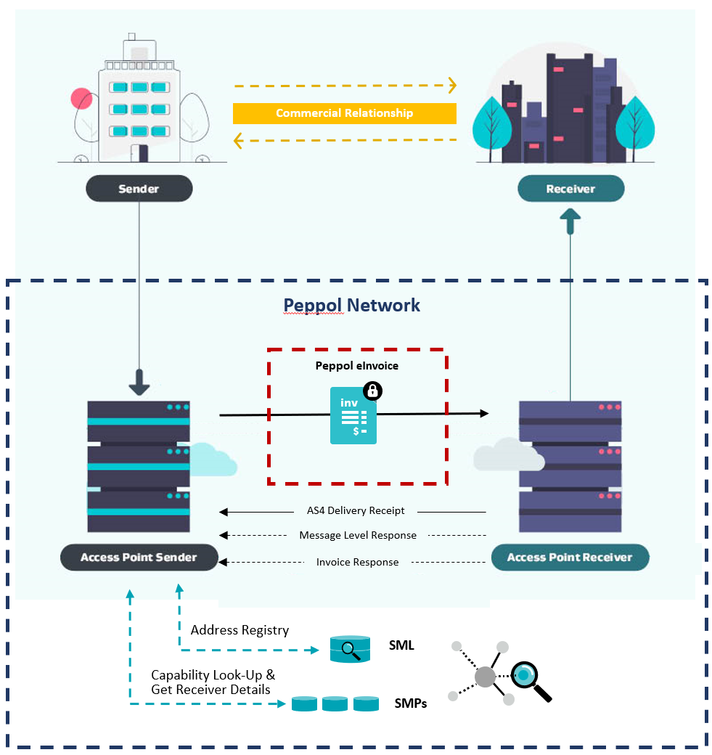

#### Change management

Sending eInvoices

* Consider how you will remember customer eInvoicing preferences (e.g. a tick box to remember customers’ eInvoicing preference and trigger this as the default future send channel)​
* How will your organisation manage the re-sending of an eInvoice if required? Refer to the [Communicating invoice status industry practice statement](https://github.com/A-NZ-PEPPOL/A-NZ-Industry-Practice-Statements/blob/main/A-NZ%20Industry%20Practice%20Statement_Communicating%20Invoice%20Status_v1.0.docx" \t "_blank)​. Note, some software products do not support the re-sending of an eInvoice. This should be checked with your chosen software provider so that any business process workarounds can be implemented.
* Implement any required process changes.

Receiving eInvoices

* Consider how you will communicate any specific requirements to suppliers (e.g. PO required).
* Peppol does not prevent the same eInvoice being sent twice - business processes should be built to work around this or FMIS should check for validations on duplicate invoice numbers.
* Implement any required process changes.

### Tips from early adopters

🞎 The goal of Peppol is interoperability between senders and receivers. Think carefully about which data fields you plan to require in supplier eInvoices. It may seem appealing to request specific data fields (e.g. requiring PO line numbers, or attachments) to aid your invoice processing – but not all suppliers will be able to provide this on an eInvoice (due to their software) so you will need to be flexible.

🞎 Ensure you’re using the [A-NZ extension to the Peppol specification](https://github.com/A-NZ-PEPPOL/A-NZ-PEPPOL-BIS-3.0), rather than the global Peppol specification.

🞎 Invest time in data mapping and be familiar early on with how the eInvoicing solution in your accounting system/common supplier systems work. Systems manage the mapping of references in different ways – for example, [Xero users](https://central.xero.com/s/article/Send-an-e-invoice-NZ) have a single reference field where users must denote reference number/s with a prefix (PO: for purchase order, CN: for contract number, PN: for project number and TN: for tender number).

🞎 Ensure your business processes have been updated to support Peppol eInvoicing.

🞎 Like any technology change, change management and customer/supplier onboarding is key to successful implementation. Refer to eInvoicing change management guide on the eInvoicing website for more information.

### Implementation task checklist

| Task | Done ✓ |
| --- | --- |
| Review current processes |  |
| Capture NZBN data   * Ask your customers for their NZBN * Search the [NZBN Register](https://www.nzbn.govt.nz/) * Consider the [Business Match service](https://www.nzbn.govt.nz/using-the-nzbn/nzbn-services/business-match/) or [NZBN API](https://www.nzbn.govt.nz/using-the-nzbn/nzbn-services/api/) if you have lots of customers * Do you need to update other documentation, supplier/customer onboarding processes and forms to capture the NZBN? |  |
| Crown invoices and organisational part numbers |  |
| Credit note handling   * Negative invoices vs credit notes |  |
| Peppol data to be passed through   * Understand what invoice content fields are available in your billing or finance system’s eInvoicing solution * Mandatory data fields * Recommended data fields (best practice, good practice and optional) * Attachments |  |
| Invoice validation and business rules |  |
| Message acknowledgements |  |

# Section 4 - Testing

Testing your eInvoicing solution is different for each organisation and your provider. Below are some key considerations. Your software and Access Point providers are key components of a robust testing phase.

### Testing considerations

#### Work with your testing partners (suppliers/customers)

Identify key customers/suppliers for your eInvoicing implementation – some of these stakeholders will become your testing partners. A strong champion to work with can make this process much faster and more efficient – so it’s worth investing the time upfront. Becoming familiar with the billing or FMIS software used by your suppliers can also assist with forming test cases later.

#### Test or production environment

One thing to consider is whether you/your partner will be sending test eInvoices to a test environment or piloting in your production environment:

* Receiving in the production environment has the benefits of being able to test how your real process and systems react to the eInvoice. You may wish to consider transmitting low value invoices with a purchase order number created specifically for testing.
* A test environment can be useful to protect existing systems but in some cases, users do not have full interface access to the FMIS, meaning the life cycle of the eInvoice may not be fully visible.

#### Monitor eInvoices

Real time monitoring of eInvoices coming in (their content/timing etc) is critical to testing efficiently. Work with your provider to ensure access to a real time view of an inbound Peppol payload (e.g. via a monitoring or gateway portal).

This will also allow you to review the contents of XML data sent and effectively troubleshoot issues.

### Testing checklist

It’s important to capture a cross section of invoices currently received by ensuring test cases include a combination of BAU and edge cases where adjustments to processes have been required.

Among the things worth testing are:

| Task | Done ✓ |
| --- | --- |
| Purchase order numbers on eInvoices (if applicable)  This is important where the supplier and/or the customer have mandatory purchase ordering in place |  |
| Mapping of references  Do the required references land in the correct place? |  |
| Manually checking details such as amounts, dates, descriptions, attachments |  |
| Invoices with single lines as well as those with multiple lines and multiple schedules |  |
| Receipt of credit notes/negative invoices |  |
| Scenarios where processes to be updated to enable eInvoicing |  |
| Different billing software  The receipt of eInvoices from the main billing or FMIS software used by your suppliers and ensuring test cases cover a range of these products. For example, many smaller suppliers may use Xero or MYOB; recruitment suppliers may use Invoxy, FastTrack360 or Envisage. It can be helpful to start by choosing a supplier using each product so that any intricacies with the product can be ironed out early, before widening the scope |  |
| Duplicate invoices  It’s important to note that the Peppol network will allow an eInvoice to be sent more than once with the same invoice number (ID). It is common for FMIS software to have built in validations to check for this. However, it is beneficial to be familiar with the functionality available. |  |
| Finance users/approvers  Checking whether your finance users/approvers identify any issues with test transactions sent, to identify any potential operational impacts ahead of time |  |

You can also ask your implementation provider for recommendations on what to test based on their experience and the systems they’ve integrated with.

# Appendix 1 – Troubleshooting

On occasion, an eInvoice does not flow through the steps as expected. At each point on its journey, an eInvoice will go through validations. Below are tips in troubleshooting these issues.

| **Issue** | **Approach** |
| --- | --- |
| eInvoice​ hasn’t arrived with receiver. Sender reports eInvoice has been sent from their accounting system and has confirmation with their access point provider that the transmission was successful. | Receiver to check tools available in Access Point Provider gateway dashboard   * Review the Invoice Line Report if one is available. This is a list of invoices received through the gateway that have made it through the standard Peppol checks eg, mandatory fields are populated.   + If “successful”, the invoice will have progressed to the next phase, being validations/checks implemented by the customer/access point, such as the value in the Order Reference field   + If “rejected”, a validation has failed on a field at the gateway. For example:     - The format of the value in the Order Reference may be not what was expected eg, PO123456 rather than PN123456, or the value mapped to the field could be entirely incorrect.   + Confirm the error and revert to the business process implemented to manage exceptions. This may involve having the supplier re-send the invoice either as an eInvoice or a PDF, with the corrected information. *Note, it is likely your access point provider can implement message responses where the sender and/or receiver are advised of transmission issues at the gateway.* * If the invoice does not appear on the Invoice Line Report, ascertain the date and time on which the invoice was sent, and review the inbound messages to identify if the XML file arrived.   + If the XML file can be located, review the file contents for any obvious errors. Alternatively, have your access point provider review it for you.   + If the XML file cannot be located, pass the available information on to your access point provider for further investigation. |
| Invoice has arrived at the gateway successfully, but it has not flowed through to the supplier record in the customer’s accounting system. | As the eInvoice passes to the receiver’s accounting system, it will likely be subject to further validations.  An example of a validation at this stage, is where the sender’s NZBN is not loaded against the supplier record in the receiver’s accounting system, hence a match cannot be found. The user should check the supplier record for the NZBN and update as necessary, and manually process the invoice. |
| Exception Queues | When the eInvoice fails validations in the receiver’s accounting system, then it will likely land in an exception queue where users will need to troubleshoot the cause and correct before manually pushing it through the approval process. The queue/s should be regularly monitored by users to maintain efficient processing of supplier invoicing. |