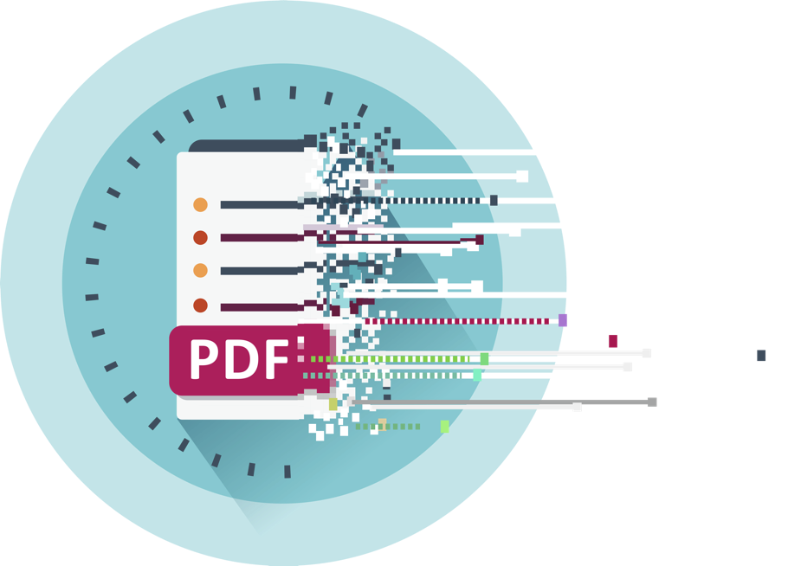

Supplier onboarding

In-Person ‘Event in a Box’ Resource

November 2024

Table of Contents

In-Person ‘Event in a Box’ resource 3

This resource is for organisations who want to provide a personal touch to helping suppliers transition to sending you eInvoices, instead of PDFs. 3

Purpose/objectives: 3

High level plan and timelines 4

Which suppliers to invite – selection criteria 5

Event considerations 5

Appendix one: Templated communication material 7

Appendix two: Event co-ordinator option 12

# In-Person ‘Event in a Box’ resource

## This resource is for organisations who want to provide a personal touch to helping suppliers transition to sending you eInvoices, instead of PDFs.

This practical in-person ‘working session’ is in addition to the other communication activity recommended to get your suppliers onboard. (See [einvoicing-communication-toolkit-getting-your-suppliers-ready-for-einvoicing.docx (live.com)](https://view.officeapps.live.com/op/view.aspx?src=https%3A%2F%2Fwww.einvoicing.govt.nz%2Fassets%2FeInvoicing%2Feinvoicing-communication-toolkit-getting-your-suppliers-ready-for-einvoicing.docx&wdOrigin=BROWSELINK)) You could run this event yourself or consider running it with your local Chamber of Commerce. They may be able to do a lot of the ‘heavy lifting’ of running the event for you.

This event is aimed at the accounts people or accounts receivable people within your suppliers’ business who use Xero or MYOB for invoicing. They are not necessarily the business owners. You want the ‘doers’ to attend – ie those that currently prepare and send you invoices.

|  |
| --- |
| **eInvoicing benefits you and your suppliers** The more businesses exchange eInvoices, the more you all enjoy the cashflow and productivity gains eInvoicing brings. |

### Purpose/objectives:

Running this event:

* Demonstrates to your suppliers how easy it is to send eInvoices to you (and other businesses).
* Gives your suppliers the confidence to switch to sending you eInvoices instead of emailing you PDF invoices. And therefore, means you receive more eInvoices.
* Ensures your suppliers apply the invoice reference requirements you need, from the outset.
* Helps your business achieve the productivity gains eInvoicing brings.

### High level plan and timelines

| Task | Timing |
| --- | --- |
| Planning:   * Secure an event co-ordinator. * Investigate and decide/book venue, date and time. (Allow 1.5 hours) * Secure presenters * Communication material * Catering * On the day logistics   Tip: the middle of the month works for most accounts people | T – 7 weeks  (eg T = date of event, minus 7 weeks) |
| Prepare website event and registration pages.  Consider using online event service like [Eventbrite](https://www.eventbrite.co.nz/l/registration-online/). | T - 6 weeks |
| Determine supplier selection criteria and develop mailing list of suppliers to invite | T – 6 weeks |
| Prepare content for email invites, including reminder invite, reminder to attend emails and post-event emails  See email template content | T- 6 weeks |
| Prepare event presentation , pre and [post](#_Post-event_poll_(at) event polls and run sheet | T-3 to 5 weeks |
| Prepare and deploy invite to register for event email | T-5 weeks |
| Prepare and deploy reminder to register for event email  (depending on registration numbers) | T-3 weeks  And maybe T-2 weeks |
| Organise/order catering | T-2 days to 2 weeks |
| Prepare and deploy reminder 1 to attend email | T-1 week |
| Prepare and deploy reminder 2 to attend email | T- 1 day |
| Event day logistics:  Create run sheet: Catering, name tags, room set up (tables and chairs), signage, technology – microphones, presentation screens, QR codes (for pre and post event polls), prize and prize draw | Event day |
| Post-event follow up email 1  Thanks for attending, event survey, share any resources/presentation, reminder of CTA | T+2 days |
| Post-event follow up email 2  Reminder to send your organisation eInvoices instead of PDFs. Provide them with your NZBN and any invoice reference requirements. | T+2 weeks or 1 month |

### Which suppliers to invite – selection criteria

This ‘Event in a box’ resource has been specifically developed to target your suppliers who use Xero or MYOB. You could narrow this to those who regularly invoice you.

However, you could adapt it for other groups of suppliers like a particular sector who may use a similar invoicing system.

Most small businesses use Xero or MYOB accounting packages. Xero and MYOB users can send and receive eInvoices at no extra cost, so they’re a quick win. You can choose to have one working session for just Xero users or just MYOB users.

Suppliers using Xero or MYOB can be identified in your invoice inbox. Invoices being sent from the cloud-based version of small business accounting software are sent from the following generic email addresses.

* [AccountRight@apps.myob.com](mailto:AccountRight@apps.myob.com) or similar email address for MYOB
* [messaging-service@post.xero.com](mailto:messaging-service@post.xero.com) or similar for Xero

*Could your service provider, OCR provider help with this task?*

Check to see if they’re already registered to receive eInvoices. If they can receive eInvoices, chances are they also send eInvoices.

[New Zealand businesses registered to receive eInvoices [XLSX, 16 MB]](https://www.einvoicing.govt.nz/assets/eInvoicing/nz-businesses-registered-to-receive-einvoices.xlsx?vid=24)

Reaching the right person within your supplier’s organisation: Most organisations record the supplier’s email address for remittance advices. This is likely to be the email address accounts people use – so the right people to invite to attend this event.

### Event considerations

#### Sponsorship or partner with others to reduce the cost

During tight economic times and to share the costs, consider seeking sponsorship from your eInvoicing service provider, MYOB and Xero; and/or partnering up with another organisation who may have similar suppliers. Local Chambers of Commerce may be able to help with the event co-ordination and put a partnership/sponsorship proposal together to suit your situation. See appendix two.

#### Presenters

It’s best to have a subject matter expert (and someone who is comfortable with presenting) to lead and run the session.

* It could be your eInvoicing Champion, your eInvoicing service provider, your Accounts Payable Manager or Team lead.
* Consider asking a local Xero or MYOB representative to attend, to support you. If they can’t attend, ensure your presenter gets familiar with Xero and/or MYOB’s eInvoicing user interface/experience/instructions.
* MBIE’s eInvoicing team may also be able to assist or support in Auckland or Wellington-based events. Contact them at [einvoicing@mbie.govt.nz](mailto:einvoicing@mbie.govt.nz).
* Account payable team leads or managers should also attend if they’re not presenting, so they’re on hand to support attendees during the session.

#### Incentive to encourage attendance

Everyone is busy so how can you ensure those that register turn up on the day? In addition to the personal/business benefits of attending the session, you may also want to add another incentive to ensure attendance. It could be a prize draw for a Prezzy Card or some other prize.

#### Allow invoices to come through with an incorrect purchase order

If your organisation only accepts invoices with a purchase order (PO) number, on the day of the event you could allow attendees to send a $1 invoice with a purchase order number that is in the correct format but not a valid PO.

For example, if your PO format is PO + 6 digits, you could allow an eInvoice with PO999999 to reach your finance system. This is likely to create a manual process, but you can provide instructions to your team to delete it after it has come through.

This way attendees get to experience sending an eInvoice with minimal impact to your organisation.

### Appendix one: Templated communication material

#### Event landing page (on your website)

**Location:** <physical address>

**Event Date:** <date>

**Time:** Arrive from <time> for a <time + 30 minutes> start - <finish time>

**Cost:** Free. Morning tea supplied.

**Register Now!**

**Transition to eInvoicing and reduce your admin burden, get paid faster and improve cashflow.**

Is your business still sending or receiving PDF invoices via email?

It’s time to make the switch to eInvoicing - the smarter way of invoicing that saves time and helps your business get paid faster.

Join us for an informative and hands-on session designed to help accounts people, accountants, and finance managers transition smoothly to eInvoicing.

<We've partnered with <partner> to/We> bring you this special event that will demystify the eInvoicing process and show you how it can streamline your invoicing tasks, reduce errors, and improve cash flow. Say goodbye to PDFs and paper invoices and embrace the future of invoicing.

Why Attend?

* **Learn from Experts:** Gain insights from eInvoicing specialists who will guide you through the setup process.
* **Network with Peers:** Connect with fellow finance professionals over morning tea.
* **Boost Productivity:** Discover how eInvoicing improves productivity.
* **Win Prizes:** Enter our Prezzy Card prize draw.

What We’ll Cover:

* **Enabling eInvoicing:** Step-by-step instructions to activate eInvoicing on your accounting system (if you haven’t done so already).
* **Finding NZBNs:** Learn how to locate your NZBN and the NZBNs of your trading partners.
* **Send and receive eInvoices:** Practical demonstrations on sending and receiving eInvoices.
* **Resources to make the most of eInvoicing.**
* **Q&A Session:** Get answers to all your eInvoicing questions.

Who Should Attend?

This workshop is ideal for finance professionals responsible for managing accounts payable and receivable. If your business uses <Xero Business Edition or MYOB Business/AccountRight> and you’re involved in the invoicing process and want to make it more efficient, this session is for you.

What to Bring:

To make the most of this hands-on session, please bring your work laptop and ensure you have access to your accounting system.

**Register Today.**

Don’t miss this opportunity to streamline your invoicing process and improve your business productivity. Secure your spot for our <date> workshop now.

We look forward to seeing you there! *Register button* ***(button – links to registration page*)**

#### Event Registration page

**eInvoicing workshop event <date and time>:**

Secure your attendance today by completing the following:

Name:

Organisation:

NZ Business Number for your organisation:

Email address:

Accounting system used:

List any dietary requirements:

#### Registration acknowledgement email

Subject line: Thank you for registering!

Kia ora, NAME,

Thank you for registering to attend our upcoming <name or organisation> eInvoicing session.

If you have any specific questions that you would like answered, feel free to send them to me ahead of time.

If you would like a refresher on what we will be covering, you can click the link here.

 Here are the details for your calendar:

Location: **<location, physical address>**

Event date: **<date>**

Time: **<start and finish time>**

Looking forward to seeing you there.

Ngā mihi,

Name

#### Invite to register for event email

Subject line: You’re invited: <name > eInvoicing Workshop

Kia Ora,

As a supplier to <name of your organisation> we’d like to extend a warm invitation to an eInvoicing workshop <hosted by <name of hosting party/ our accounts payable team>.

You may be aware that <name of your organisation> prefers to receive eInvoices instead of emailed PDF invoices. The good news is <Xero/MYOB> users can easily send and receive eInvoices, free of charge.

To help you get started, we’ve teamed up with <event partner> to **host a special eInvoicing session** for those responsible for invoicing in your businesses – accounts people, accountants, and finance managers.

The goal of the session is to get you set up for eInvoicing and send and receive eInvoices in real time, so please bring your work laptop.

You’ll get hands-on guidance to get going.

**Date:** <day, date>  
**Time:** <start to finish time>  
**Location:** <venue>

Morning tea will be provided. Plus, attend and you’ll be in the draw for a <$150 Prezzy Card/or other suitable incentive>.

Please register your attendance here *<link to web page*>. We’d love to see you there.

Ngā Mihi,

Name/title

#### Reminder to register email

Subject line: Reminder, register for <name > eInvoicing Workshop

Kia Ora,

This is a reminder to register your spot at the upcoming <name> eInvoicing workshop. Places are filling up but it’s not too late. Register today.

As a supplier to <name of your organisation> we’d love to see you.

To help you get started with sending eInvoices for the goods or services you provide us, we’ve teamed up with <event partner> to **host a special eInvoicing session** for those responsible for invoicing in your businesses – accounts people, accountants, and finance managers.

The goal of the session is to get you set up for eInvoicing and send and receive eInvoices in real time, so please bring your work laptop.

**Date:** <day, date>  
**Time:** <start to finish time>  
**Location:** <venue>

Morning tea will be provided. Plus, attend and you’ll be in the draw for a <$150 Prezzy Card/or other suitable incentive>.

Please register your attendance here *<link to web page*>. We’d love to see you there.

Nga Mihi,

Name/title

#### Reminder to attend email (1 week out and 1 day prior)

Kia ora,

We’re looking forward to seeing you at the eInvoicing training session <next week/tomorrow>, at <time>. We’ll be serving morning tea from <time>, so if you can make it earlier, we’d love you to join us.

 Remember, this is a working session so **don’t forget to bring your work laptop**.

*Optional*

 <**Please respond to this email** (even if just with a single smile emoji!) by **<2 days before the event>** to confirm you will be attending on <day>. As this is a free, catered event, we want to ensure we have a good idea of numbers.

Haven’t yet registered your business to receive eInvoices? While it’s not critical, as we’ll cover this off in the session, please consider registering your business to receive eInvoices in your Xero or MYOB account before the session.

Follow the instructions on Xero or MYOB’s websites:

[Register to receive - Xero](https://central.xero.com/s/article/Register-to-receive-e-invoices-NZ)

[eInvoicing - MYOB](https://www.myob.com/nz/support/myob-business/sales/einvoicing)

 Looking forward to seeing you there.

Ngā mihi,

Name

#### Event presentation

Available on request from [einvoicing@mbie.govt.nz](mailto:einvoicing@mbie.govt.nz)

#### Pre-event poll

Before the session starts gauge attendees’ perception and confidence with eInvoicing:

Do you currently send or receive eInvoices?

* Yes
* No

How confident are you about switching to eInvoicing?

* Very confident
* Somewhat confident
* Not very confident
* Not sure

Do you plan on switching to eInvoicing?

* Already use it
* Plan on using it more
* Plan to start using it
* Not sure
* Don’t think so

#### Post-event poll (at the end of the session)

Did you find this event useful?

* Very useful
* Somewhat useful
* Not very useful
* Not useful at all

How likely are you to recommend eInvoicing to others?

* Very likely
* Somewhat likely
* Not very likely
* Not likely at all

What could be improved for future events?

* More Q&A time
* More networking time
* More practical information
* Other (please specify)

How confident are you about sending and receiving eInvoices?

* Very confident
* Somewhat confident
* Not very confident
* Not sure

Do you planning on switching to eInvoicing?

* Already using it
* Plan to switch
* Plan to use it more
* Not sure

Any other feedback?

#### Post event follow up email

Kia ora koutou,

Thank you for attending the <name> eInvoicing workshop today. We hope you got some value out of the session and feel confident in being able to send us eInvoices instead of PDF invoices. The more businesses exchange eInvoices, the more you all enjoy the cashflow and productivity gains eInvoicing brings.

Remember:

* Add our NZBN to the <name of your organisation> customer record: <NZBN number> so your invoices reach the right place
* Always include <a purchase order number/enter other reference requirements here> in the reference part of the invoice <*include PO format if required*>

*Optional:*

*As promised, see attached slide deck of the presentation for your reference.*

*As mentioned, we would greatly appreciate hearing how you found the event. Please click the link below to fill out our 1.5-minute survey.*

*eInvoicing Session Survey (add link)*

Remember, next time you need to invoice us, send an eInvoice instead of a PDF. If you have any further feedback or questions, email us at <email address>

Ngā mihi nui,

Name/title

### Appendix two: Event co-ordinator option

If you are based in the regions listed below, Business Central can work with you to manage the co-ordination of this event and provide support in seeking sponsor partnerships.

* Te Upoko/Wellington
* Manawatū-Whanganui
* Taranaki
* Te Matau/Hawkes Bay
* Tairāwhiti/Gisborne
* Whakatū/Nelson

Please contact Freya for more information.

 Freya Slessor (she/her)  
*Programmes & Sustainability Advisor*

[Freya.slessor@businesscentral.org.nz](mailto:Freya.slessor@businesscentral.org.nz)

Level 13, NTT Tower, 157 Lambton Quay, Wellington 6011